Objective Questions for chapter 12

- Consider the following CFG which is in CNF
S → PQ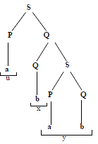
Q → QS|b
P → a

The word which generated by CNF above is :

- abab
- aaba
- abba
- aabb

- Consider the language EVENA i.e.
EVENA=(aa)^{n} =a2^{n} ={aa, aaaa, aaaaaa, …}
The grammar for this language must be
S → SS|aa and its CNF will be
S → SS|AA, A → a, the PDA for this grammar will be as under…
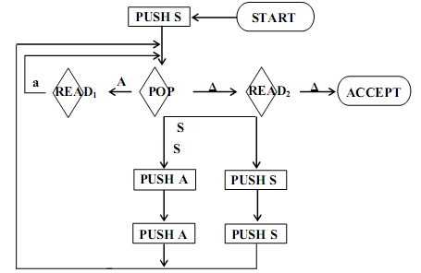
a.

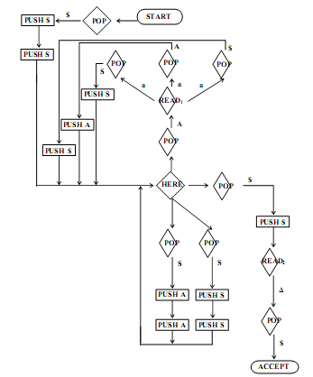
b.

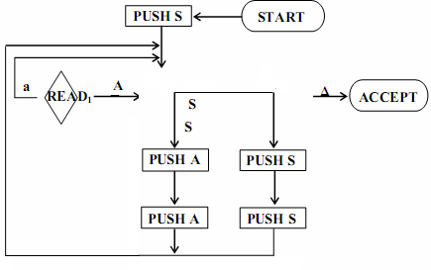
c.

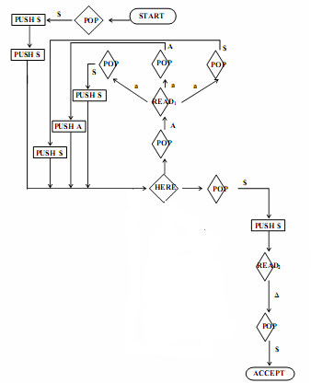
d.

- which is the final state for
S→AB, A →BSB, B→CC
C→SS
A→a|b
C →b|bb?
a. S→abb
b. S→aab
c. S→S|ab
d. S→S|A|C|b

- what the algorithms that convert the CFG into CNF ?
  - Let the string x under consideration has the form x=x1x2x3…xn here all x is may not be different.
  - Let the string x under consideration has the form x=x1x2x3…xn here all x is may be different.
  - Let the string x up consideration has the form x=x1x2x3…xn here all x is may not be different.
  - Let the string x up consideration has the form x=x1x2x3…xn here all x is may be different.

- Which is the step of algorithm except!!!
  - Stop if a self-embedded nonterminal is discovered.
  - To test whether X is self-embedded
  - Change all X’s on the right of the productions into a Greek letter Ψ and keep all X’s on the left side as such.
  - Paint all X’s blue.

- Give the example of Parsing Techniques !
  - S→(S+S)|(S*S)|number
S ➔E
➔F+E
➔T+E
➔i+E
➔i+T
➔i+F*T
➔i+i*T
➔i+i*F
➔i+i*i
  - S→(S+S)|(S*S)|number
S ➔E
➔T+E
➔i+E
➔F+E
➔i+T
➔i+F*T
➔i+i*T
➔i+i*F
➔i+i*i
  - S→(S+S)|(S*S)|number
S ➔E
➔T+E
➔F+E
➔i+E
➔i+T
➔i+F*T
➔i+i*T
➔i+i*F
➔i+i*i

  - S→(S+S)|(S*S)|number
S ➔E
➔T+E
➔F+E
➔i+E
➔i+T
➔i+F*T
➔i+i*F
➔i+i*T
➔i+i*i

- What the definition of Parsing of word ?

  - The process of finding the derivation of word generated by relaxed grammar.
  - The process of finding the derivation of semiword generated by particular grammar.
  - The process of finding the derivation of word generated by particular grammar
  - The process of construction the derivation of word generated by particular grammar

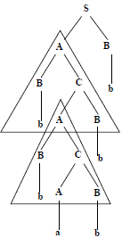from the picture we can coclude that :
a. the derivation tree of the word bbabbb
b. the derivation tree of the word bbabab
c. the derivation tree of the word ababbb
d. the derivation tree of the word bbaabb

- A production of the form nonterminal A terminal is called :

  - Dead production.
  - Live Production.
  - Just Production.
  - No answer is correct

- A production of the form nonterminal A string of two nonterminals is called :

  - Live production.
  - Dead production.
  - Just Production.
  - No answer is correct.

